Exercise 1: Creating and Running a React Application

Aim : To create a React application named ‘myfirstreact’ and display the heading "Welcome to the First Session of React" on the webpage.

Theory Questions and Answers
1. Define SPA and its benefits.
SPA (Single Page Application) is a web application that loads a single HTML page and dynamically updates content without reloading the entire page.
Benefits:
- Faster user experience
- Reduced server load
- Better performance
- Smooth navigation
- Less bandwidth consumption
- Easy integration with APIs
2. Define React and identify its working.
React is an open-source JavaScript library developed by Meta Platforms for building user interfaces, especially single-page applications.
Working of React:
- React creates a Virtual DOM.
- User actions trigger state changes.
- React compares the new Virtual DOM with the old one.
- Only the changed elements are updated in the Real DOM.
- The UI is rendered efficiently.
3. Differences between SPA and MPA.
SPA | MPA
Loads a single page | Loads multiple pages
Faster navigation | Slower navigation
Uses JavaScript heavily | Uses server-side rendering
Better user experience | Traditional web experience
Example: React Apps | Example: Traditional websites

4. Pros and Cons of Single Page Applications.
Pros:
- Fast page loading
- Better user experience
- Less server communication
- Easy debugging
- Mobile-friendly
Cons:
- Initial loading may be slow
- SEO challenges
- Higher browser memory usage
- JavaScript dependency

5. Explain React.
React is a JavaScript library used for creating reusable UI components. It follows a component-based architecture and uses Virtual DOM to improve performance.

Characteristics:
- Component-based
- Declarative
- Efficient rendering
- One-way data flow
- Reusable code

6. Define Virtual DOM.
Virtual DOM (Document Object Model) is a lightweight copy of the Real DOM maintained by React.
Advantages:
- Faster updates
- Improved performance
- Efficient rendering
- Reduces direct manipulation of Real DOM

7. Features of React.
- Component-Based Architecture
- Virtual DOM
- JSX Syntax
- One-Way Data Binding
- High Performance
- Reusable Components
- Easy Testing
- Strong Community Support

Procedure
Step 1: Install Node.js and NPM
Download and install Node.js from:
https://nodejs.org/en/download/
Verify installation:
node -v
npm -v
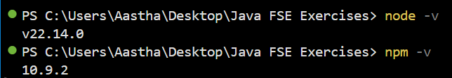

Step 2: Install Create React App
npm install -g create-react-app
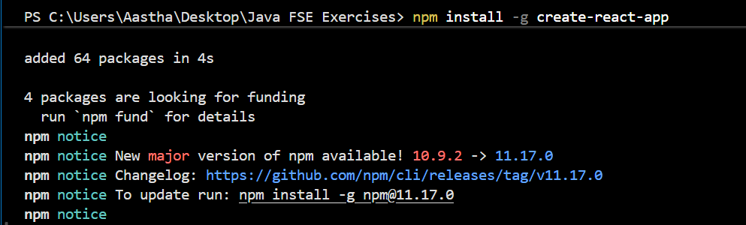
Step 3: Create React Application
npx create-react-app myfirstreact

Step 4: Navigate to Project Folder
cd myfirstreact

Step 5: Open Project in VS Code
code .

Step 6: Open App.js
Navigate to:
src/App.js
Delete the existing content and replace it with:
function App() {
return (
<div>
<h1>Welcome to the First Session of React</h1>
</div>
);
}
export default App;

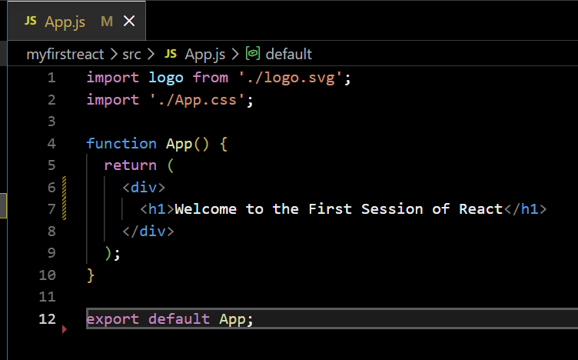

Step 7: Run the Application
npm start

Step 8: View Output
Open browser and enter:
http://localhost:3000

Output
The browser displays ‘Welcome to the First Session of React’ as a heading on the webpage.

Result
A React application named myfirstreact was successfully created and executed. The webpage displayed the heading:
"Welcome to the First Session of React".

